**1.Launched EC2 for terraform & awscli configuration**

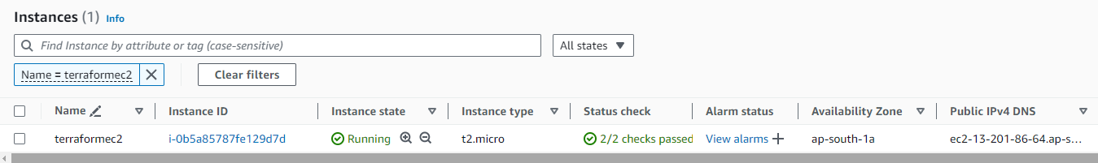

**2.Terraform & AWS CLI installed, AWS configure Done with User ID**

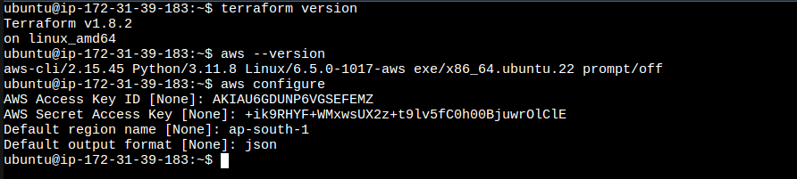

**3.User ID Access Key Generated in IAM Role**

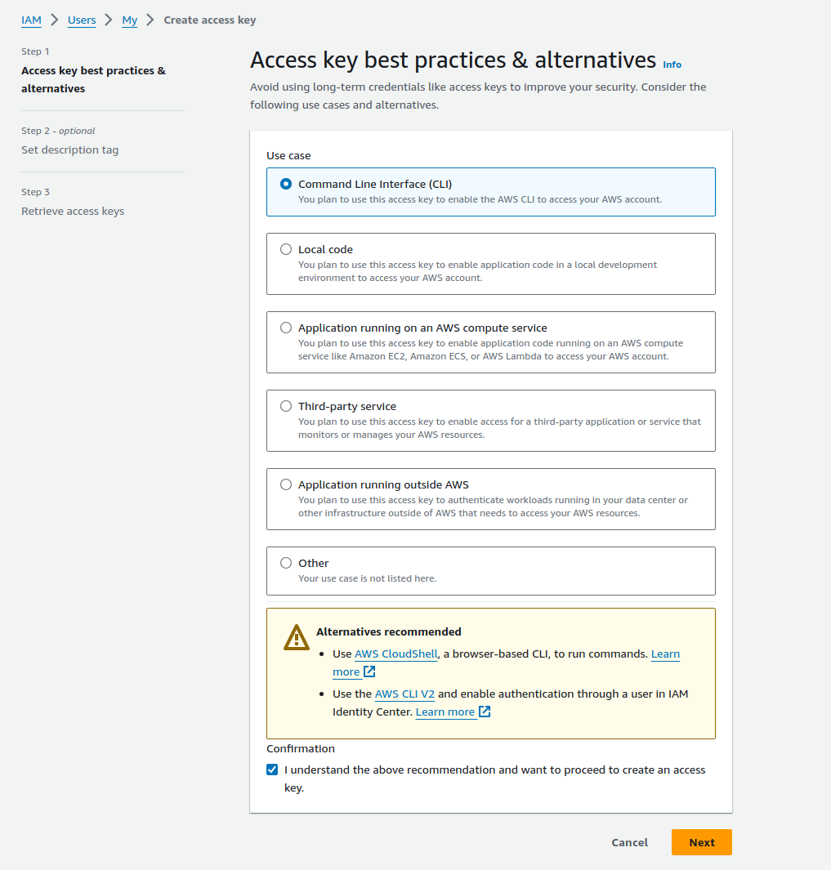

**4.Demo File Created for Terraform test**

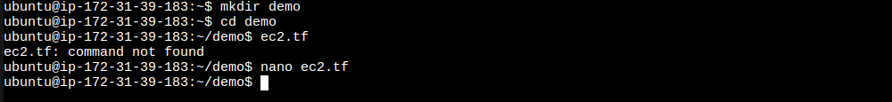

**5.Test File Script**

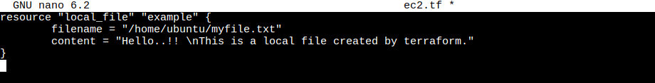

**6.Terraform initiated in Created directory**

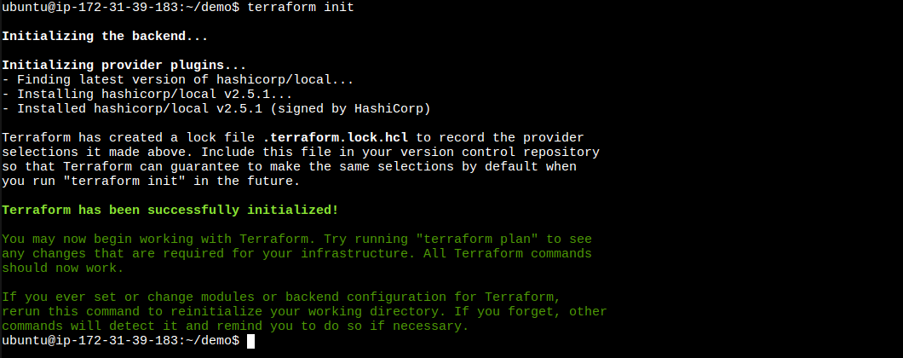

**7.Terrafrom Applied and Done**

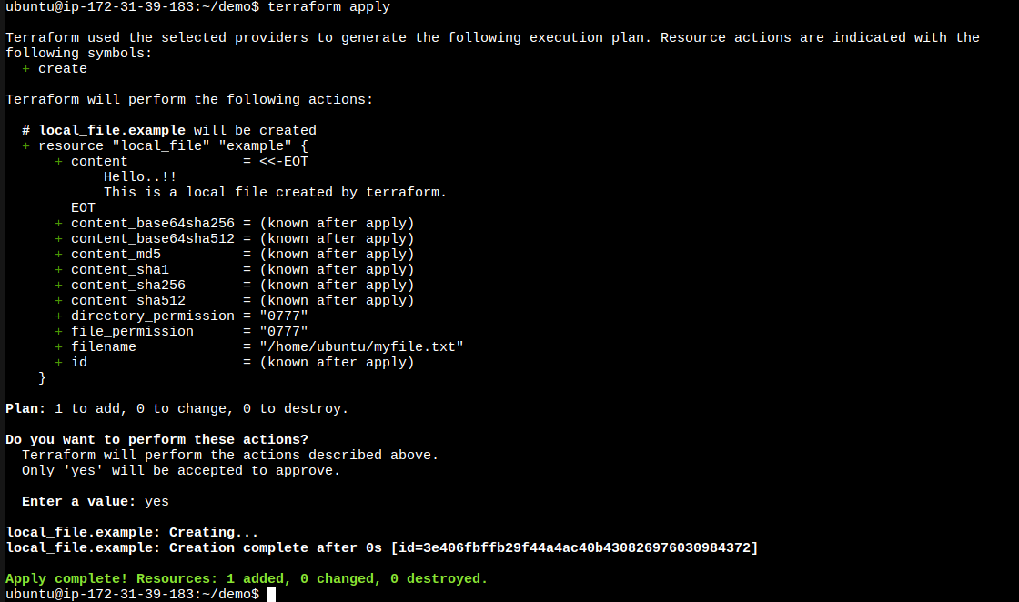

**8.Demo file Tested with Output**

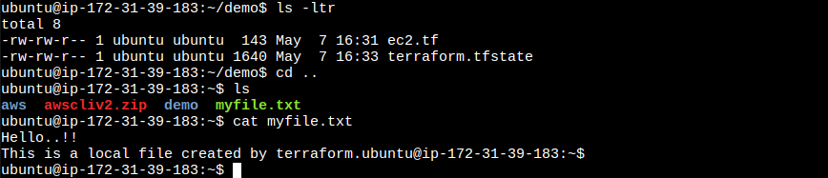

**9.Creating File for EC2 Launch in two different regions**

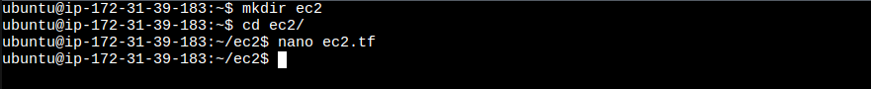

**10.Terraform Script File for Two EC2 Creation**

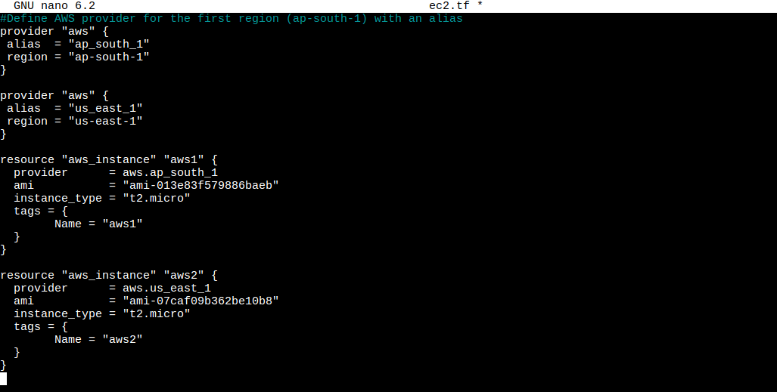

**11.Terraform Initialized in the directory**

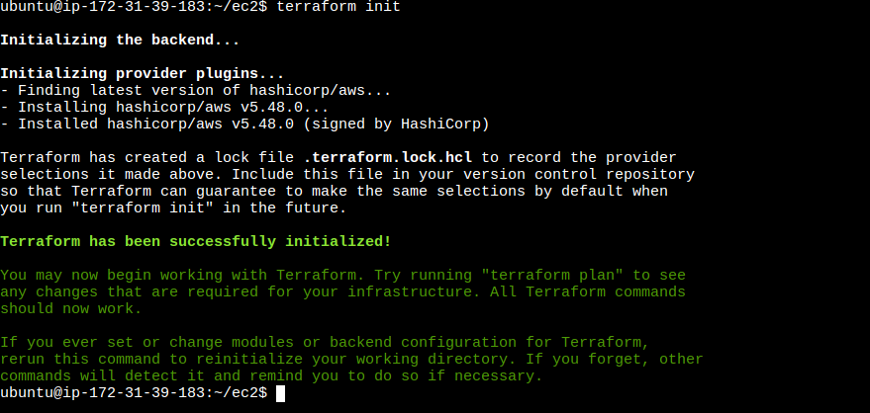

**12.Terraform Plan check. EC2 in First Region**

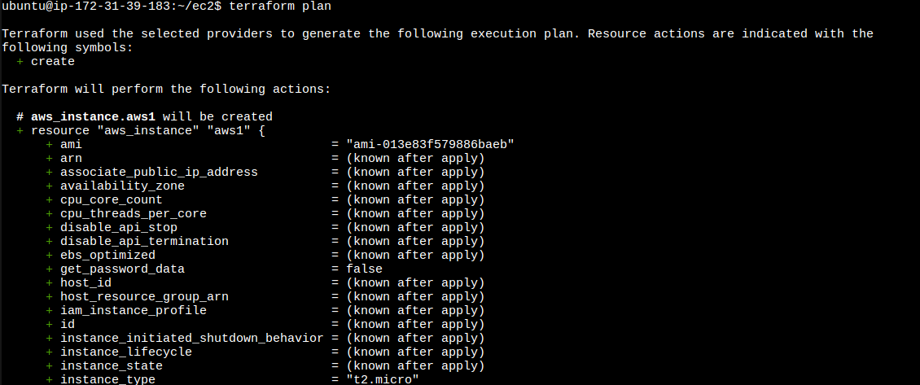

**13.EC2 Second Region Plan**

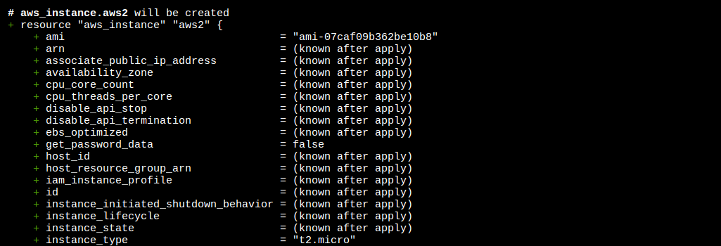

**14.Terraform applied and EC2 First Region Creating**

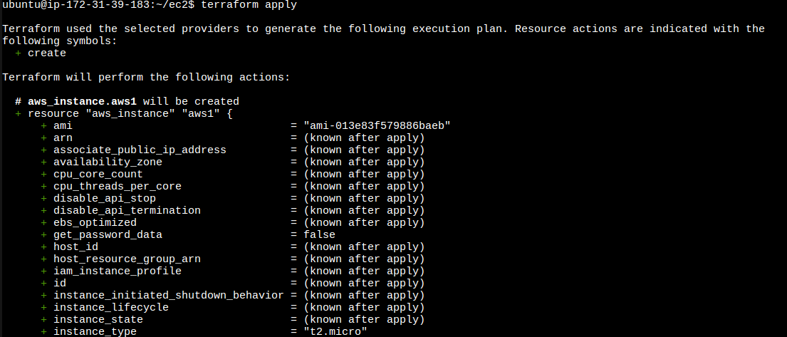

**15.EC2 Second Region Creating**

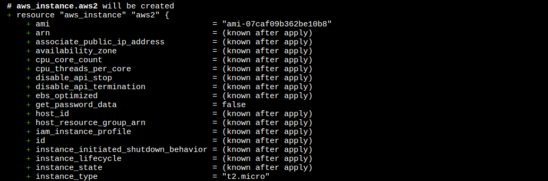

**16.Two EC2 created in Two different Regions**

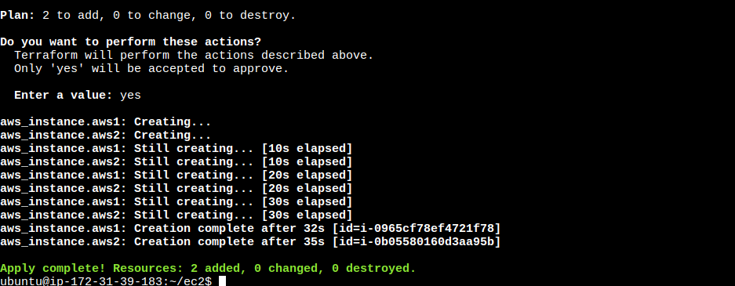

**17.EC2 Created in First Region and Running**

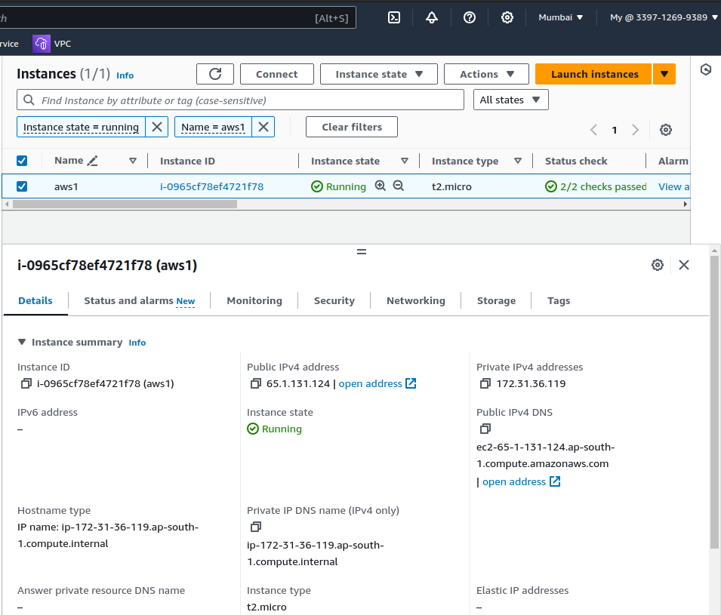

**18.EC2 Created in Second Region and Running**

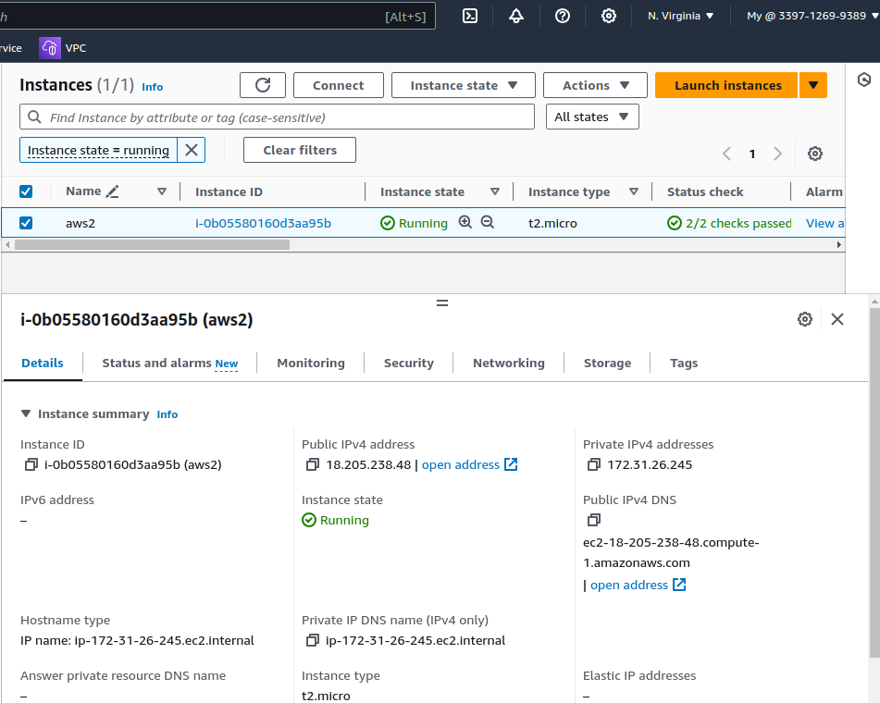

**19.EC2 Launched in First Region**

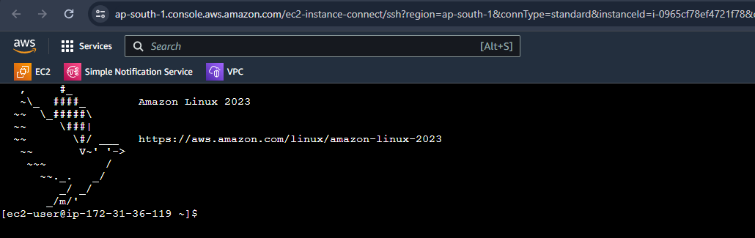

**20.EC2 Launched in Second Region**

